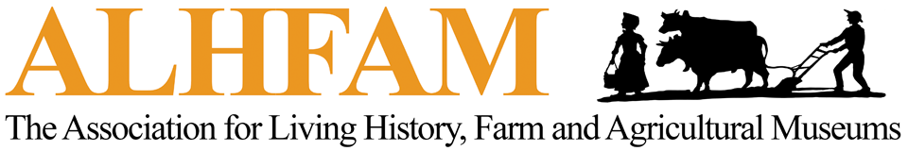

ANNUAL PLOWING MATCH
Standard Operating Procedures

Twelve Months Out

Confirm with the conference committee the desire to hold a plowing match

Nine Months Out

Confirm that a site has been found for the plowing match and that the site will be left fallow for the winter.

The site should be ¼ acre or 50’ x 100’

The conference committee should allow a minimum of two to three hours during the planning for the match to occur. This does not include travel time to and from the site.

Ensure that the site has draft animals that are experienced at plowing.
      - This may include horses, oxen or mules.
      - See more on this below (On the Day of the Match).
      - When possible, it is recommended that a back-up team be available, especially if weather conditions are warm and the animals tire out quickly.

Ensure that the site has at least one walking plow that is easy to plow with even though it might be beyond your time period. If you want to use the period plow then use it for the expert category.

Six Months Out

Begin searching for plowing match judges.

Begin a list of all who have agreed to assist.

Designate a head judge and two assistant judges.

Three Months Out

Order the plowing match ribbons (paid for by FARM PIG)

See attached Description of Ribbons and ALHFAM Logo

Ribbons Supplier: Steve McCabe, Chatam Sports, Chatam, NJ
Email: sjmccabe@chathamsports.net
Phone: 973-635-3595

Place the order for 3 sets of ribbons (Expert; Apprentice; Novice) with the logo button as shown, 1st-6th place as seen in the sample proof from 2013 (attached)

One Month Out

Confirm that all final details have been addressed and all is set for the match.

Request three clip boards and pens for judges.

Email the score sheets to the conference committee and request copies be made.

On the Day of the Match

Have the judges meet the site coordinator early before the participants get there.

When using horses, Novice and Apprentice classes should only plow and allow an experienced plowman to drive the horses. Experts (with experience plowing with horses) should plow and handle the team. The same goes for using mules.

When using oxen, participants should only be asked to plow and a drover should be designated to drive the oxen.

Have the team practiced and ready to go!

