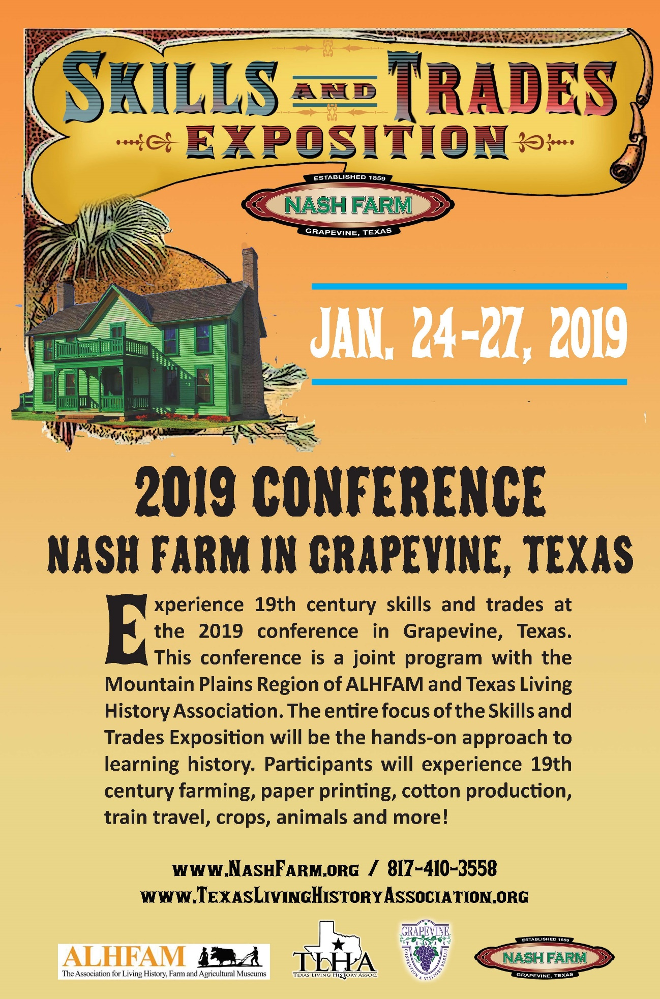

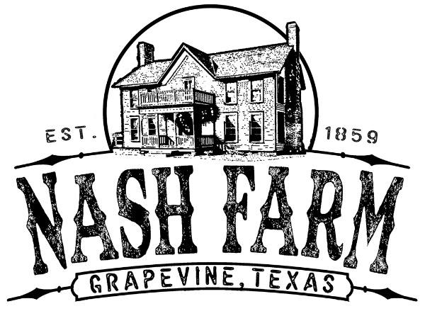

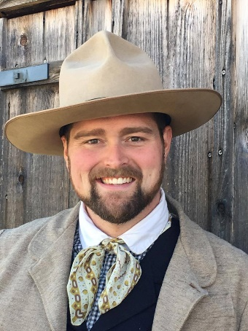Welcome to Nash Farm in Grapevine, Texas. We are proud to host the joint conference of the *Texas Living History Association* and the *Mountain Plains Region of the Association for Living History, Farm and Agricultural Museums* for the **Skills & Trades Exposition**. This year’s conference will focus on application based physical skills of the 19th century. Grapevine is a great place to showcase skills with our historic sites including our historic farm, printing press, cotton gin, railroad operations, blacksmith shop and more. We hope this year to teach ourselves as we teach visitors, through fun engaging programs.

Grapevine offers many cultural attractions to education and entertain you on your visit. Conference attendees will have the opportunity to enjoy a movie at our restored 1940 Palace Theatre, Settlement to City Museum Complex and Ice House Museum, oldest log cabin in Tarrant County, and perhaps enjoy a glass of Texas produced wine from one of our town’s wine tasting rooms. We hope to see you in Grapevine, Texas for the Skills & Trades Exposition!

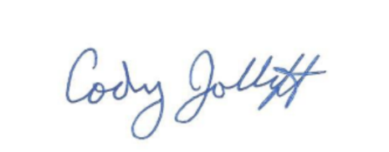

**Cody Jolliff, Nash Farm Manager**

*Heritage Programs & Preservation*

Grapevine Convention & Visitors Bureau

City of Grapevine, Texas



**Conference Committee**

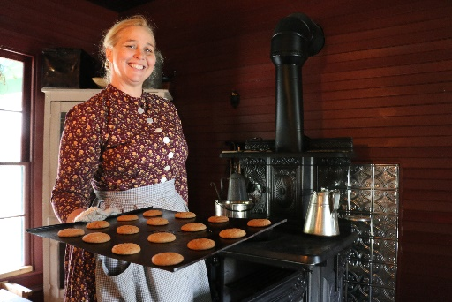

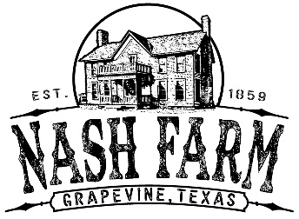**Kimberly Wageman-Prack**

*Conference Co-Chair*

**Farm Educator, Nash Farm**

Grapevine Convention & Visitors Bureau

Grapevine, Texas

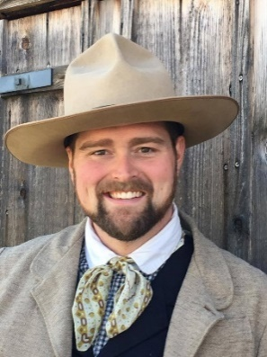

**Cody Jolliff**

*Conference Co-Chair*

**Farm Manager, Nash Farm**

Grapevine Convention & Visitors Bureau

Grapevine, Texas

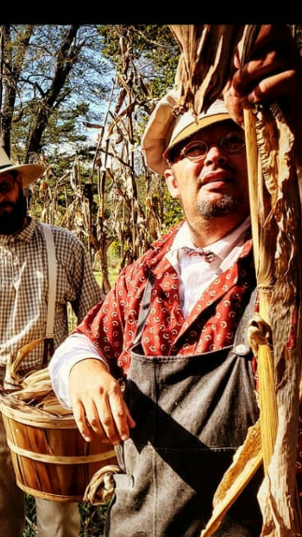[](https://www.google.com/url?sa=i&rct=j&q=&esrc=s&source=images&cd=&cad=rja&uact=8&ved=2ahUKEwjLzuHs0fzeAhVEpFkKHXgvBgsQjRx6BAgBEAU&url=https://www.poncapost.com/local/set-stone-casting-call-cemetery-tours/attachment/oklahoma-historical-society&psig=AOvVaw3Ru3U-o6hvHfptMuqcb_VT&ust=1543685249992169)**David Fowler**

*ALHFAM Mountain Plains Region Representative*

**Regional Director, Oklahoma Historical Society**

Park Hill, Cherokee Nation, Oklahoma

[](https://www.google.com/url?sa=i&rct=j&q=&esrc=s&source=images&cd=&cad=rja&uact=8&ved=2ahUKEwjYmdXZ4PzeAhVjplkKHWZdBNUQjRx6BAgBEAU&url=https://en.wikipedia.org/wiki/Texas_Historical_Commission&psig=AOvVaw35vNV1KhQe8P9iMcjui4Sb&ust=1543689235691254)**Amanda Maloney**

*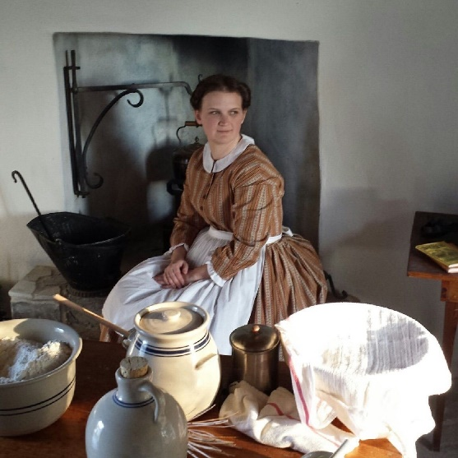Vice President, Texas Living History Association*

**Educator, Landmark Inn State Historic Site**

Texas Historical Commission

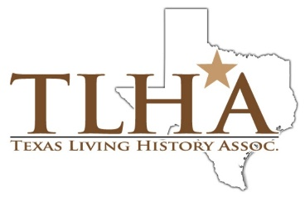

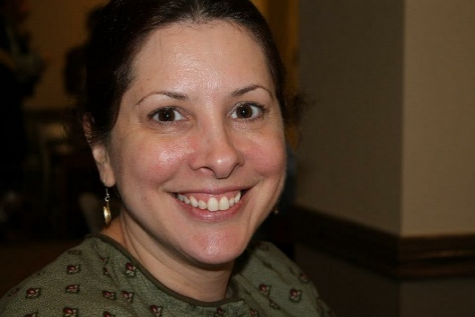**Paula Frederick**

*Treasurer*

*Texas Living History Association*

College Station, Texas

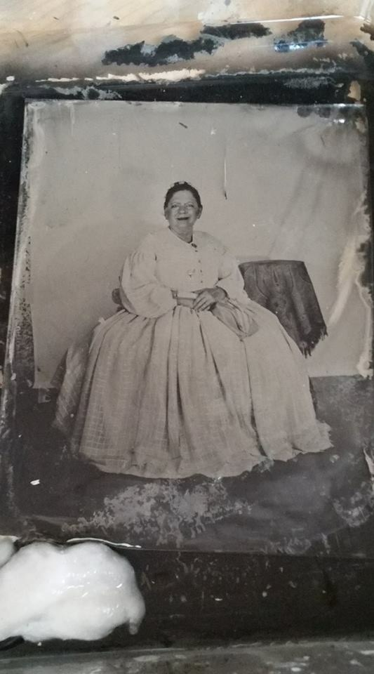

[](https://www.google.com/url?sa=i&rct=j&q=&esrc=s&source=images&cd=&cad=rja&uact=8&ved=2ahUKEwiGzbWm4fzeAhWI1VkKHXWgB0IQjRx6BAgBEAU&url=https://www.fortworth.com/listings/log-cabin-village/2392/&psig=AOvVaw1CruLNSAlfRQroISQenj3g&ust=1543689370490185)**Linda Sanders**

*Lakes/Brazos Regional Representative*

*Texas Living History Association*

**Historical Interpreter**

Log Cabin Village

Fort Worth, Texas

**Conference Registration Fees**

**Full Conference Registration**(Member TLHA or ALHFAM) $75.00

*This includes all of the conference activities except Workshops.*

Non- Member Registration $90.00

Additional Tickets to the Grand Calico Ball Saturday Evening. $25.00

**General Conference Information**

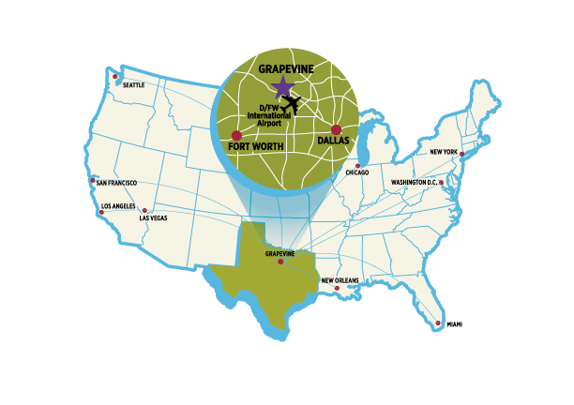

[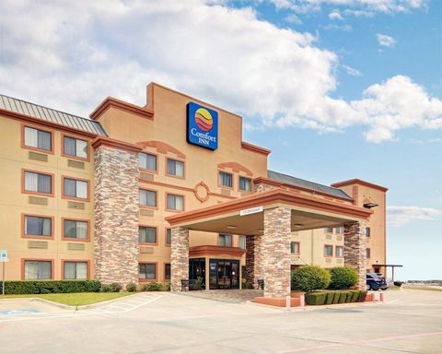](https://www.google.com/url?sa=i&rct=j&q=&esrc=s&source=images&cd=&cad=rja&uact=8&ved=2ahUKEwiro6H7kfreAhWiwVkKHah3B5EQjRx6BAgBEAU&url=https://www.choicehotels.com/texas/grapevine/comfort-inn-hotels/txf41&psig=AOvVaw2_80jl_MI9aWxU6gHB9dMz&ust=1543599382420696)**Comfort Inn**

301 Capital St., Grapevine, Texas 76051

817.329.9300 choicehotels.com

Living History Conference Rate: $89.00 per night.

Breakfast included.

[](https://www.google.com/url?sa=i&rct=j&q=&esrc=s&source=images&cd=&cad=rja&uact=8&ved=2ahUKEwiaqujAlvreAhVuqlkKHTcFDGYQjRx6BAgBEAU&url=https://www.eturbonews.com/126885/dallas-fort-worth-international-airport-launches-new-brand&psig=AOvVaw1egzAi7ff2K1Ahor1tHvWa&ust=1543600591906781)

[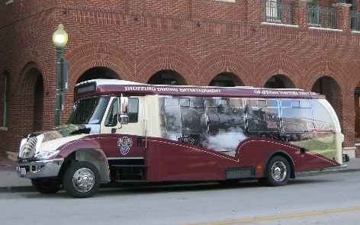](https://www.google.com/url?sa=i&rct=j&q=&esrc=s&source=images&cd=&cad=rja&uact=8&ved=2ahUKEwjop9-8mPreAhUj01kKHfaIBWkQjRx6BAgBEAU&url=https://www.grapevinetexasusa.com/listing/shuttle-stop-b/614/&psig=AOvVaw2sig822zF8I3-o_lA9QBfw&ust=1543601130246938)If traveling by air, you’ll want to fly to DFW International Airport. This airport is located in Grapevine, Texas and is a 3.8 miles from the conference hotel. A five-dollar shuttle service from the airport leaves from the Grand Hyatt DFW at the top of every hour, Monday – Saturday 10 a.m. – last bus leaves airport at 10 p.m. Ask the driver to take you to the stop near Comfort Inn on Main Street.

**On-site Conference Registration**

**Founders Building**

Cotton Belt Historic Railroad District

701 S. Main St. Grapevine, Texas 76051

***Look for the Expo Logo Banner!***

**Wednesday, January 23     12 Noon – 6 p.m.**

**Thursday, January 24          7:30 a.m. – 5 p.m.**

**Friday, January 25               7:30 a.m. – 5 p.m.**

**Saturday, January 26          7:30 a.m. – 10 a.m.**

**Parking**

Public Parking is FREE citywide in Grapevine, Texas.

Participants may wish to drive their car to and from sites such as Nash Farm and Railroad District.

**Vendor Exhibits**

The vendor exhibit area is located in Founders Building inside the Cotton Belt Historic Railroad District. Vendors will be provided with banquet tables, chairs, and black linens upon request by emailing CJolliff@GrapevineTexasUSA.com

Vendors are asked to kindly donate an item to the Auction for their booth space fee.

**Auction Items**

Auction items will be accepted at registration until registration closes at 10 a.m. Saturday.

**2019 Conference Overview**

**Wednesday, January 23**

Noon – 6 p.m. Registration Open at Founders Building

Noon – 6 p.m. Vendor Set-Up at Founders Building

**Thursday, January 24**

7:30 a.m. – 5 p.m. Registration Open at Founders Building

7:30 a.m. – 5 p.m. Vendor Set-Up at Founders Building

8:00 a.m. – 4 p.m. Farmers Institute (Day 1), Nash Farm

8:00 a.m. – 4 p.m. Rail Crew Academy, Cotton Belt Depot

9:00 a.m. – 4 p.m. Wrapper Workshop (Day 1), Founders Building

9:00 a.m. – 11:00 p.m. Historic Downtown Grapevine Walking Tour, Founders Building

9:00 a.m. – 12:00 p.m. Blacksmithing: Make a Steel Striker

1:00 p.m. – 4:00 p.m. Blacksmithing: Forge Welding

1:00 p.m. – 3:00 p.m. Historic Building Architectural Tour, Palace Theatre

3:30 p.m. – 5:30 p.m. Wine & Viticulture Class, Tour and Tasting, Delany Vineyards

7:30 p.m. **Palace Movie Theater showing of “The Egg and I” 1947**

*Get in the mood and wear your 1940s attire! Popcorn & Soda Included.*

Sponsored by the Grapevine Heritage Foundation

**Friday, January 25**

7:30 a.m. – 5 p.m. Registration Open at Founders Building

8:00 a.m. – 4:00 p.m. Farmers Institute (Day 2), Nash Farm

9:00 a.m. – 4:00 p.m. Wrapper Workshop (Day 2), Founders Building

9:00 a.m. – 4:00 p.m. The Sheep Are Sheared, Now What?, Nash Farm Windmill

9:00 a.m. – 4:00 p.m. Historic Land Surveying, Settlement to City Museum Complex

9:00 a.m. – 4:00 p.m. Basic Blacksmithing, Millican’s Blacksmith Shop

9:00 a.m. – 4:00 p.m. Historical Broom Making, Nash Farm Pole Barn

9:00 a.m. – 4:00 p.m. Cooking for a Social Event, Nash Farmhouse Kitchen

9:00 a.m. – Noon Constructing Canvas: Tent and Fly Setup

9:00 a.m. – Noon Spark and Flame: Historical Fire-Making Skills

1:00 p.m. – 3:00 p.m. Rags to Rugs, Settlement to City Museum Complex

1:00 p.m. – 3:00 p.m. Flints, Caps, Cartridges: Firearms of the Past, Nash Farm Pasture

6:00 p.m. – 8:00 p.m. **Farmhands Gathering at Nash Farm**

*Welcome Reception – Bring a salted, pickled or preserved item if you wish.*

**Saturday, January 26**

7:30 a.m. – 10 a.m. Registration Open at Founders Building

8:00 a.m. – 9:00 a.m. Coffee Break at Millican’s Blacksmith Shop

9:00 a.m. – Noon 45 min hands-on sessions

**Noon Rail Crew Lunch – Founders Building**

*(Business Meeting)*

2:00 p.m. – 4:00 p.m. 45 min hands-on sessions

4:00 p.m. – 5:00 p.m. Round Table on Volunteer Recruitment

**Grand Calico Ball**

[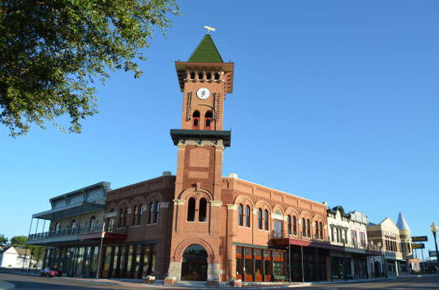](http://www.google.com/url?sa=i&rct=j&q=&esrc=s&source=images&cd=&cad=rja&uact=8&ved=2ahUKEwjZ2I6_nITfAhVns1kKHQtpDPUQjRx6BAgBEAU&url=http://www.grapevinetxonline.com/city-links/&psig=AOvVaw3OY6WLUo10IcOsMOJJ0H1_&ust=1543945794652621)**Grapevine Convention & Visitors Bureau’ Visitors Center**

636 S. Main St. Grapevine, Texas

*Living History Attire Requested*

6:00 p.m. – 7:00 p.m. Reception & Silent Auction

*Second Floor Rotunda*

7:00 p.m. – 9:00 p.m. **Grand Calico Ball,** Live Auction & Awards

*Grand Hall*

**Sunday, January 27**

8:00 a.m. – 9:00 a.m. Coffee Break at Millican’s Blacksmith Shop

9:00 a.m. – Noon 45min Sessions

Noon Conference Concludes ***Lunch on your own in Historic Downtown Grapevine!***

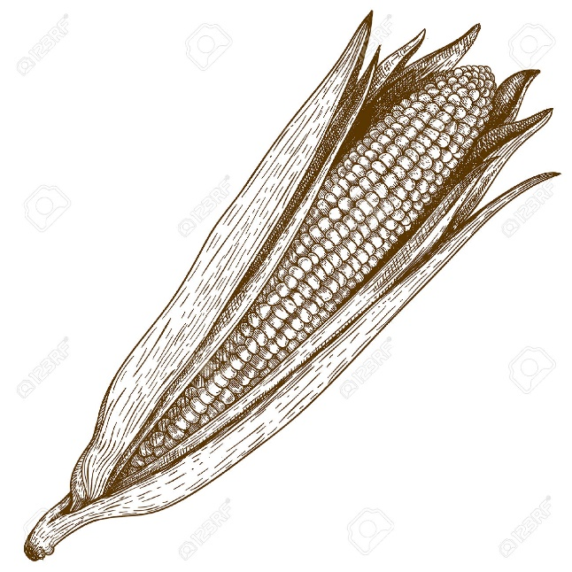**Exposition of Goods**

Showcase your Skills & Trades at the Exposition of Goods. Attendees who have produced something may put the items on display in the Founders Building for the Exposition of Goods. Each item will be provided with a tag for information, and be in the running for a blue ribbon. If the exhibitor wishes the item may also be in the auction, notation will be on the form. Examples of items, wheat, corn, textiles, canned fruits and vegetables, tin cup, blacksmith-made item, wood items. If you wish to bring a something large or odd, such as a rooster, please coordinate ahead of time.

**Thursday Tours & Workshops**

**Thursday, January 24**

7:30 a.m. – 5 p.m. Registration Open at Founders Building

7:30 a.m. – 5 p.m. Vendor Set-Up at Founders Building

8:00 a.m. – 4 p.m. Farmers Institute (Day 1), Nash Farm

8:00 a.m. – 4 p.m. Rail Crew Academy, Cotton Belt Depot

9:00 a.m. – 4 p.m. Wrapper Workshop (Day 1), Founders Building

9:00 a.m. – 11:00 p.m. Historic Downtown Grapevine Walking Tour, Founders Building

9:00 a.m. – 12:00 p.m. Blacksmithing: Make a Steel Striker

1:00 p.m. – 4:00 p.m. Blacksmithing: Forge Welding

1:00 p.m. – 3:00 p.m. Historic Building Architectural Tour, Palace Theatre

3:30 p.m. – 5:30 p.m. Wine & Viticulture Class, Tour and Tasting, Delany Vineyards

7:30 p.m. Palace Movie Theater showing of “The Egg and I” 1947

*Get in the mood and wear your 1940s attire! Popcorn & Soda Included.*

Sponsored by the Grapevine Heritage Foundation

[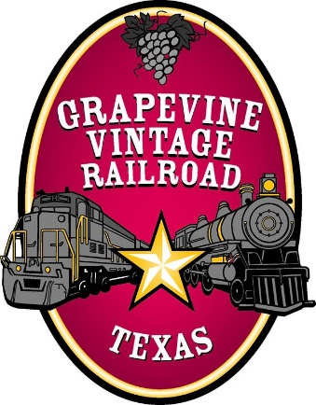](https://www.google.com/url?sa=i&rct=j&q=&esrc=s&source=images&cd=&cad=rja&uact=8&ved=2ahUKEwi75tuD8ITfAhUQw1kKHXBxAlgQjRx6BAgBEAU&url=https://hulafrog.com/arlington-tx/grapevine-vintage-railroad/&psig=AOvVaw0MqfQomwg-SxolHhBmbWDv&ust=1543968172240558)

**Rail Crew Academy $50.00 Thursday 8:00 a.m. – 4:00 p.m.**

**Instructor: Dwight Fegley & Grapevine Vintage Railroad Crews**

**Participants: 15**

**Location: Cotton Belt Depot, Cotton Belt Historic Railroad District**

Learn the basic of historic railroading on a working vintage railroad. Academy participants will have class sessions on the mechanics of the train, learn the positions on a rail crew, learn the braking system, assist with operating a turn table, tour train coaches and engines, see a steam locomotive being restored and much more. Fee includes lunch, classroom supplies, etc.

[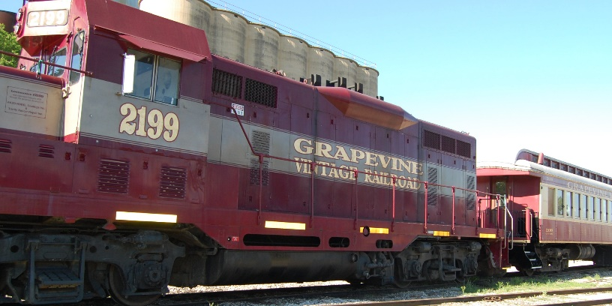](http://www.google.com/url?sa=i&rct=j&q=&esrc=s&source=images&cd=&cad=rja&uact=8&ved=2ahUKEwiZpeHq74TfAhVJzlkKHfWFCSIQjRx6BAgBEAU&url=http://www.ilovegrapevinetexas.com/event/after-christmas-trains/&psig=AOvVaw0MqfQomwg-SxolHhBmbWDv&ust=1543968172240558)



[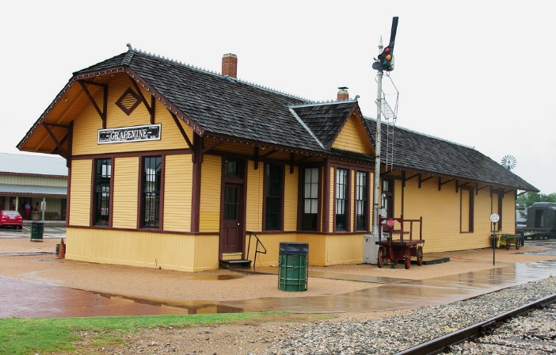](https://www.google.com/url?sa=i&rct=j&q=&esrc=s&source=images&cd=&cad=rja&uact=8&ved=2ahUKEwjGksHJ8ITfAhUtvlkKHVW2B-0QjRx6BAgBEAU&url=https://www.flickr.com/photos/84263554@N00/7359788802&psig=AOvVaw3Jj60mAfWh6vqo7pIfdP4I&ust=1543968369686049)

**Thursday Continued**



**Make a steel striker $30.00 Thursday 9:00 a.m. – Noon**

**Instructor: Kelly Kring, *Instructor & Professional Blacksmith, Brookhaven College, Farmers Branch, Texas***

**Participants 9**

**Location: Millican’s Blacksmith Shop, Cotton Belt Railroad District.**

Forge your own steel striker at the blacksmith forge. Participants will create their own early 19th century style steel striker. Flint provided too. Participants must wear natural fiber clothing, long sleeves and boots.

**Forge Welding Primer $30.00 Thursday 1:00 p.m. – 4:00 p.m.**

**Instructor: Timothy Phillips, Texas Living History Association**

**Participants 5**

**Location: Millican’s Blacksmith Shop, Cotton Belt Railroad Dist.**

A basic blacksmithing session devoted to forge welding low carbon steel. Participants should be able to make a useful item to keep. Participants must wear natural fiber clothing, long sleeves and boots.

[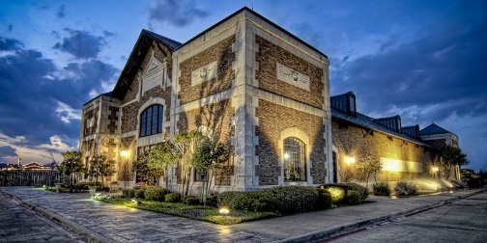](https://www.google.com/url?sa=i&rct=j&q=&esrc=s&source=images&cd=&cad=rja&uact=8&ved=2ahUKEwiJ59uvwYTfAhUOlKwKHbG9B9cQjRx6BAgBEAU&url=https://www.winecountry.com/businesses/4010/delaney-vineyards&psig=AOvVaw2MIQFlIp6Vxfc8hLyh2h4v&ust=1543955706164013)

**Wine & Viticulture Class, Tour and Tasting $30.00**

**Thursday 3:30 p.m. – 5:30 p.m.**

**Instructor: Debbie Reynolds, Grapevine Wine Pouring Society**

**Location: Delany Vineyards** 2000 Champagne Blvd, Grapevine, Texas

Experience Grapevines agriculture legacy as it ventures into wine production. Class participates will tour the vineyard and bottling facilities, wine tasting. Participants must be 21 & over.

[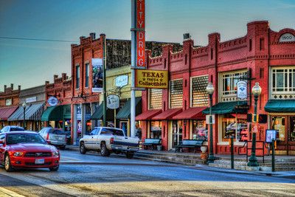](https://www.google.com/url?sa=i&rct=j&q=&esrc=s&source=images&cd=&cad=rja&uact=8&ved=2ahUKEwjTou2R24TfAhUEmVkKHfaQBAsQjRx6BAgBEAU&url=https://www.pinterest.com/pin/274086327297127336/&psig=AOvVaw1y0P8WvfSVVO4UZhid04xY&ust=1543962617233400)

**Historic Downtown Grapevine Walking Tour FREE**

**9:00 a.m. – 11:00 a.m.**

**Instructor: Sallie Andrews, *Historian, Grapevine Heritage Programs & Preservation***

***Grapevine Convention & Visitors Bureau***

**Location: Meet at Founders Building, Cotton Belt Historic Railroad District**

Learn the fascinating story of Settlement from the 1840s to what stands today in historic downtown Grapevine. Grapevine Historian Sallie Andrews will give a walking tour up Main Street with engaging stories of how this town came to be. Participants can enjoy a lunch at one of downtown’s award winning restaurants, then rejoin the group for the afternoon architectural tour.

**Thursday Continued**

[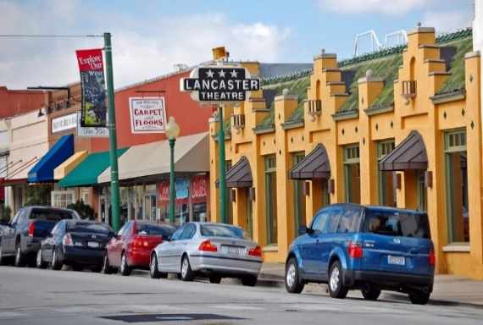](https://www.google.com/url?sa=i&rct=j&q=&esrc=s&source=images&cd=&cad=rja&uact=8&ved=2ahUKEwjTou2R24TfAhUEmVkKHfaQBAsQjRx6BAgBEAU&url=https://www.flickr.com/photos/wdnew71/3667132824&psig=AOvVaw1y0P8WvfSVVO4UZhid04xY&ust=1543962617233400)**Historic Building Architectural Tour FREE 1:00 p.m. – 3:00 p.m.**

**Instructor: David Klempin, Historic Preservation Officer & Manager of Grapevine Heritage Programs & Preservation, *Grapevine Convention & Visitors Bureau***

**Location: Meet at Founders Building, Cotton Belt Historic Railroad District**

Experience historic architecture of Grapevine from the 1840s to the Post Civil War era and beyond with Architect David Klempin. Mr. Klempin has been the Historic Preservation Officer overseeing all historic building projects downtown and in the historic homes’ township for over 15 years.

[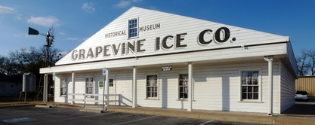](https://www.google.com/url?sa=i&rct=j&q=&esrc=s&source=images&cd=&cad=rja&uact=8&ved=2ahUKEwjHwIjT24TfAhXNuVkKHRKECJIQjRx6BAgBEAU&url=https://grapevinehistory.weebly.com/museums.html&psig=AOvVaw0kY704wc0Fb_ZhTftSgXVH&ust=1543962761404938)

**Settlement to City Museum Complex Tour FREE 10:00 a.m. – 4:30 p.m. Ongoing**

**Instructor: Grapevine Museum Staff & Volunteers**

**Location: Settlement to City Museum – Located behind the Visitors Center at 636 S. Main**

Explore the Settlement to City Museum Complex including; Ice House Museum, Settlement to City exhibit in the Keeling Home, Donald Schoolhouse, Cotton Gin Museum & Ted R. Ware Plaza.

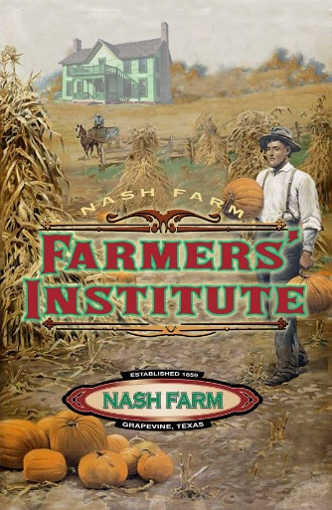

**Farmers’ Institute Nash Farm $50.00 Thursday & Friday**

***Two Day Workshop:*** Thursday, January 24 & Friday, January 25,8:00 a.m. – 4:00 p.m.

**Lead Instructor: David Fowler, Oklahoma Historical Society**

20 Participants Accepted

The Farmers’ Institute is a full two days of experience based learning in agriculture, animal care and more. The institute will include care of chickens & turkeys, draft horse driving, winter agricultural work, sheep care & more. Participants are encouraged to wear historic farming attire and bring a historical cup to drink from. Dinner plates and hot lunches each day will be provided. All in attendance must wear long sleeve shirts, pants or dress, and boots.

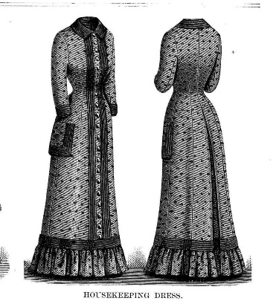

**Two Day Wrapper Dress Workshop $90.00 Thursday & Friday**

**Instructor: Marna Davis, Maven, The Domestic Lady’s Dressmaker**

**Participants: 20**

**Location: Founders Building, Cotton Belt Railroad District**

***Two Day Workshop:*** Thursday, January 24 & Friday, January 25

9:00 a.m. – 4:00 p.m.

Make a late 19th century wrapper style dress with Marna at Founders Building. Class fee includes a kit with fabric, pattern and supplies needed. Bring sewing machine if you have one. Lunch provided at Nash Farm on Friday only. Lunch on your own Thursday in historic downtown Grapevine.

**Thursday Continued**

**Supper on your own in Historic Downtown Grapevine then join us for a movie!**

**[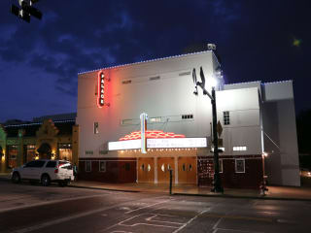](http://www.google.com/url?sa=i&rct=j&q=&esrc=s&source=images&cd=&cad=rja&uact=8&ved=2ahUKEwixrszmxYTfAhVMOK0KHeeTDIAQjRx6BAgBEAU&url=http://fortworth.culturemap.com/eventdetail/palace-theatre-presents-classic-film-series/&psig=AOvVaw0ekYHzR771bIHjJBPavYrJ&ust=1543956877026773)Palace Movie Theater showing of**

**“The Egg and I,” 1947**

**Time: 7:30 p.m.**

**Location: Palace Arts Center**

**FREE ADMISSION & REFRESHMENTS!**

***Get in the mood and wear your 1940s attire!***

***Popcorn & Soda Included.***

**Welcome by the Grapevine Heritage Foundation**

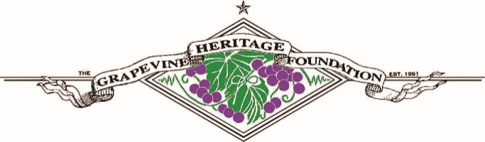*Sponsored by the Grapevine Heritage Foundation*

*World War II veteran Bob MacDonald (Fred MacMurray) surprises his new wife, Betty (Claudette Colbert), by quitting his city job and moving them to a dilapidated farm in the country. While Betty gamely struggles with managing the crumbling house and holding off nosey neighbors and a recalcitrant pig, Bob makes plans for crops and livestock. The couple's bliss is shaken by a visit from a beautiful farm owner (Louise Allbritton), who seems to want more from Bob than just managing her property.*

[](https://www.google.com/url?sa=i&rct=j&q=&esrc=s&source=images&cd=&cad=rja&uact=8&ved=2ahUKEwi89dGgu5bfAhUMvVkKHfe-CPsQjRx6BAgBEAU&url=https://www.pinterest.com/pin/369647081911933459/&psig=AOvVaw2DPRtQEMdJ6iNvIAVpR_E9&ust=1544572517714151)In the heart of Historic Downtown Grapevine, you'll find the beautifully restored Art Deco-style Palace Arts Center, home to the Palace Theatre and the Lancaster Theatre.

Threatened with closure in 1991, the historic Palace Theatre, built in 1940, was acquired by the [Grapevine Heritage Foundation](https://www.grapevinetexasusa.com/partners-locals/grapevine-heritage-foundation/) to save the building from imminent demolition. The Palace served as the premiere entertainment venue for all of Northeast Tarrant County for many years. The 1930s Buckner Cash Grocery Store, now the Lancaster Theatre, which was also acquired by the Foundation, has been restored to its Spanish, Mediterranean-style design.

The gem of Main Street, the Palace Arts Center provides visitors a unique opportunity to experience the warmth of downtown's turn-of-the-century atmosphere recognized by the National Register of Historic Places. The Palace Arts Center features performances, movies, visual arts and unique settings for business meetings, banquets, parties and receptions.

**Friday, January 25**

7:30 a.m. – 5 p.m. Registration Open at Founders Building

8:00 a.m. – 4:00 p.m. Farmers Institute (Day 2), Nash Farm

9:00 a.m. – 4:00 p.m. Wrapper Workshop (Day 2), Founders Building

9:00 a.m. – 4:00 p.m. The Sheep Are Sheared, Now What?, Nash Farm Windmill

9:00 a.m. – 4:00 p.m. Historic Land Surveying, Settlement to City Museum Complex

9:00 a.m. – 4:00 p.m. Basic Blacksmithing, Millican’s Blacksmith Shop

9:00 a.m. – 4:00 p.m. Historical Broom Making, Nash Farm Pole Barn

9:00 a.m. – 4:00 p.m. Cooking for a Social Event, Nash Farmhouse Kitchen

9:00 a.m. – Noon Constructing Canvas: Tent and Fly Setup

9:00 a.m. – Noon Spark and Flame: Historical Fire-Making Skills

1:00 p.m. – 3:00 p.m. Rags to Rugs, Settlement to City Museum Complex

1:00 p.m. – 3:00 p.m. Flints, Caps, Cartridges: Firearms of the Past, Nash Farm Pasture

6:00 p.m. – 8:00 p.m. **Farmhands Gathering at Nash Farm**

*Welcome Reception – Bring a salted, pickled or preserved item if you wish.*

**Friday Workshops**

**All Friday Workshops both full & half day workshops include lunch at Nash Farm. Lunch is served at Noon.**

**- - - - - - - - Full Day Workshops - - - - - - - -**

**Farmers Institute (See Thursday’s Description)**

**Wrapper Dress (See Thursday’s Description)**

**The Sheep Are Sheared, Now What? $30.00 Friday 9:00 a.m. – 4:00 p.m.**

**Instructors: Kathy Dickson, Director, Historic Sites & Museums, Oklahoma Historical Society**

**Jennifer Frazee, Historical Interpreter, Hunters Home, Oklahoma Historical Society**

**Participants: 12**

**Location: Nash Farm, meet at the windmill.**

That pile of dirty smelly wool looks nothing like the soft roving you spin. Learn how to clean your fleece and prepare it for spinning, or dye it in the wool and make felt. Dress to stay warm and get dirty! Lunch Provided.

**Historic Land Surveying $30.00 Friday 9:00 a.m. – 4:00 p.m.**

**Instructors: Tim and Sharlene Richardson, Arkansas Living History Association**

**Participants: 18**

**Location: Settlement to City Museum Complex**

Historic land surveying deals with the history, equipment and processes of surveying land during the early 19th century following the purchase of the Louisiana Territory from France in 1803. It will briefly highlight the first survey of the Louisiana Purchase and some of the reasons for the urgency for this survey. Examples of typical 19th century survey equipment will be used to explain how the surveys were accomplished. The first part if the session will deal with the history and techniques while the second part will be hands on with participants getting the chance to handle and use the equipment. Lunch Provided.

**Basic Blacksmithing $30.00 Friday 9:00 a.m. – 4:00 p.m.**

**Instructor: Kelly Kring, Instructor & Professional Blacksmith, Brookhaven College, Farmers Branch, Texas**

**Participants 9**

**Location: Millican’s Blacksmith Shop, Cotton Belt Railroad Dist.**

Learn the basics of blacksmithing, from how to start and care for your coal fire to the different kinds of iron and steel. Participants should be comfortable talking about blacksmithing and working at a forge by the end of the day. Participants must wear natural fiber clothing, long sleeves and boots. Lunch Provided.

**Historical Broom Making $45.00 Friday 9:00a.m.-4:00 p.m.**

**Instructor: John Potter, Partner, Republic of Texas Broom Shop and 1800s General Store, San Marcos, Texas**

**Participants: 10**

**Location: Nash Farm Pole Barn**

Learn about making brooms the way they were made in the late 1700s and early 1800s. A truly American craft, all aspects of broom making have unique ties to our early history. Learn how terms such as “putting a square peg in a round hole” to” flying off the handle” evolved from broom making while making your own broom. Lunch Provided.

**Cooking for a Social Event $30.00 Friday 9:00 a.m. – 4:00 p.m.**

**Instructor: Kimberly Wageman-Prack, Farm Educator, Nash Farm, Grapevine, Texas**

**Participants: 12**

**Location: Nash Farmhouse Kitchen**

Be ready to spend the day in the Nash Farm Kitchen whipping up delights to impress your friends and families. Participants will learn how to make such dainties as cheese straws, chicken croquette, savory patties, and a fancy dessert or two. Bring your apron. Lunch Provided.

**- - - - - - - - Friday Morning Workshops - - - - - - - -**

**Constructing Canvas: Tent and Fly Setup $10.00 Friday 9:00 a.m. - Noon**

**Instructor: Kevin Malcolm, Interpreter, Fort McKavett State Historic Site**

**Participants: 20 participants**

**Location: East Lawn, Nash Farm**

Often the first and last steps reenactors take at events is setting up their tents and flys for the weekend. This tedious process doesn’t have to be painful. Learn how to quickly and efficiently erect a basic wedge tent, wall tent, and shade fly along with other configurations that may better suit your impression or event space limitations. Participants will also learn folding practices as well as supply making tips. Lunch Provided

**Spark and Flame: Historical Fire-Making Skills $30.00 Friday 9:00 a.m. - Noon**

**Instructors: Henry B. Crawford, Living History Consultant, History By Choice**

**William Armstrong, Director, Fort Vasquez Museum**

**Participants: 15**

**Location: Nash Farm Pasture**

Hands on workshop on making no match fires using three methods: bow and drill, flint and steel, and magnifying glass. Also techniques on building an effective fire lay and maintaining a good burn. Wet and dry wood techniques will be visited as well. Lunch Provided.

**- - - - - - - - Friday Afternoon Workshops - - - - - - - -**

**Rags to Rugs $25.00 Friday 1:00 p.m. – 3:00 p.m.**

**Instructor: LaJuanna Faught, Texas Living History Association**

**Participants: 20**

**Location: Cotton Gin Museum, Settlement to City Museum Complex**

Nothing was wasted, fabric too worn or stained had a new life as floor coverings. Learn about several of the different methods employed to make an attractive yet utilitarian rug. In this hands on session, participants will learn the “toothbrush” rug making technique by completing a “Rug Mug”. Lunch Provided.

**Flints, Caps, Cartridges: Firearms of the Past $30.00 Friday 1:00 p.m. – 4:00 p.m.**

**Instructors: Henry B. Crawford, Living History Consultant, History By Choice**

**William Armstrong, Director, Fort Vasquez Museum**

**Participants: 16**

**Location: Nash Farm Pasture**

More than just how to shoot, learn identification, preservation, safety, and care of 18th century to near modern historical firearms. Lunch Provided.

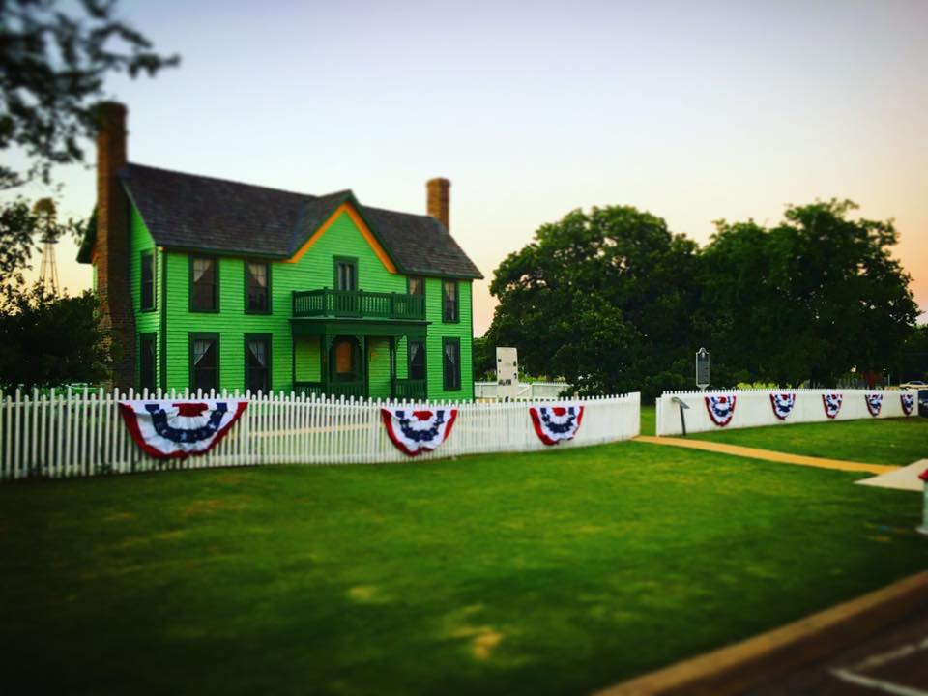6:00 p.m. – 8:00 p.m.

**Farmhands Gathering at Nash Farm**

626 Ball St., Grapevine, Texas

***Welcome Reception – Bring a salted, pickled or preserved item if you wish.***

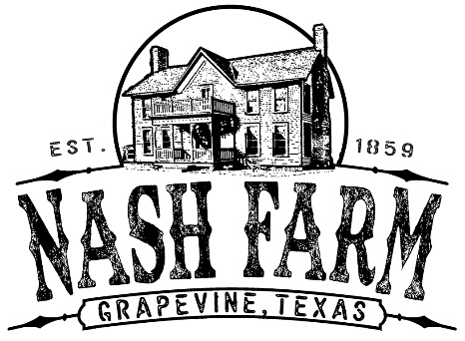**Experience farm fresh foods on the farm with the Lone Star String Band performing period music. Shop the Farm Store & tour the historic 1869 farmhouse, 1905 barn, smoke house, poultry coops and more.**

[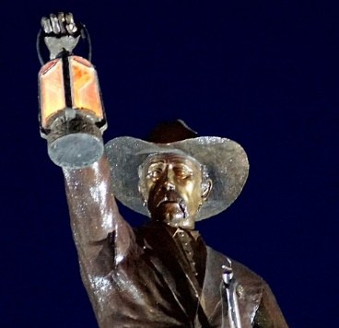](https://www.google.com/url?sa=i&rct=j&q=&esrc=s&source=images&cd=&cad=rja&uact=8&ved=2ahUKEwjutaCX74TfAhVFp1kKHaicD6sQjRx6BAgBEAU&url=https://www.grapevinetexasusa.com/listing/grapevine-nightwatchman/107/&psig=AOvVaw116jU-bViTJqoOQw36Fjd-&ust=1543967998149246)

**Good Night Farmers.**

**Don’t let the Grapevine Night Watchmen take you to the calaboose!**

*Night Watchman is a bronze public art piece above City Hall depicting Grapevine’s earliest law officer.*

**Saturday, January 26**

7:30 a.m. – 10 a.m. Registration Open at Founders Building

8:00 a.m. – 9:00 a.m. Coffee Break at Millican’s Blacksmith Shop

9:00 a.m. – Noon 45 min hands-on sessions & Blacksmith Open Shop

Noon Rail Crew Lunch – Founders Building

*(Business Meeting)*

2:00 p.m. – 4:00 p.m. 45 min hands-on sessions

4:00 p.m. – 5:00 p.m. Round Table on Volunteer Recruitment

**Grand Calico Ball**

[](http://www.google.com/url?sa=i&rct=j&q=&esrc=s&source=images&cd=&cad=rja&uact=8&ved=2ahUKEwjZ2I6_nITfAhVns1kKHQtpDPUQjRx6BAgBEAU&url=http://www.grapevinetxonline.com/city-links/&psig=AOvVaw3OY6WLUo10IcOsMOJJ0H1_&ust=1543945794652621)**Grapevine Convention & Visitors Bureau’ Visitors Center**

636 S. Main St. Grapevine, Texas

*Living History Attire Requested.*

6:00 p.m. – 7:00 p.m. Reception & Silent Auction

*Second Floor Rotunda*

7:00 p.m. – 9:00 p.m. **Grand Calico Ball,** Live Auction & Awards *Grand Hall*

**Coffee at Millican’s Blacksmith Shop Saturday 8:00 a.m.**

**Location: Millican’s Blacksmith Shop, Cotton Belt Historic Railroad Dist.**

Try your hand at the forge. Participants will have the opportunity to try their hand at blacksmithing on a come and go basis.

**45 Min Skills & Trades Sessions**

**Sessions will begin at the top of each hour, lasting 45min allowing for 15min to move to the next session.**

**Parking is available at all locations if participants wish to drive to and from.**

**Butchering and Dressing Chickens for the Stewpot Saturday 9:00 a.m.**

**Instructors: Kelsey Patton, Owner- Spindle, Shuttle, and Needle, Stromsburg, Nebraska**

**Volunteer Interpreter, Sturh Museum of the Prairie, Grand Island, Nebraska**

**Kimberly Wageman-Prack, Farm Educator, Nash Farm, Grapevine, Texas**

**Participants 10 max for hands-on experience**

Learn how to butcher and dress chickens, including “dispatching,” plucking, and dressing. Be advised, there will be boiling water, guts and blood. Once dressed, you will learn how to joint the chicken for the fry pan.

**Sewing Machine Foot Savvy Saturday 9:00 a.m.**

**Instructor: Marna Davis, Owner, The Domestic Lady’s Dressmaker**

**Location: Founders Building, Cotton Belt Historic Railroad District**

Most period sewing machines came with useful feet designed to help the home seamstress accomplish tasks with more speed. Learn to recognize and use several of these commonly seen sewing machine feet. We will also discuss the availability of these feet for modern machines, covering gathering foot, ruffle foot, hemming foot, binding foot and perhaps others.

**Harnessing Horsepower Saturday 9:00 a.m.**

**Instructors: Ken and Anne Murray, Workhorse Ranch & Olde Tyme Carriage Co., Boyd, Texas**

**Participants: 16 max**

**Location: Red Barn Corral, Nash Farm**

Participants will learn the different parts of both the single and team harness as well as how to properly fit and harness a horse.

**Brass Rubbings Saturday 9:00 a.m.**

**Instructor: Kimberly Hodges Hale, Nash Farmhand, Grapevine, Texas**

**Location: Nash Farm Cemetery**

Brass and gravestone rubbing was a popular pastime in the 19th century for making keepsakes of travels and lost loved ones. In this session participants will get the opportunity to learn the how, what, where and why of brass rubbing and then try their hand at the art form.

**Elderberry Tonic Saturday 9:00 a.m.**

**Instructor: Kimberly Pete, Nash Farmhand, Nash Farm, Grapevine, Texas**

**Location: Nash Farmhouse Kitchen**

Elderberry tonic is one of many remedies which is regaining popularity as people look to step away from “Big Pharma,” Many of us are asked about older remedies and while many of them should remain firmly in the past, elderberry tonic is regaining popularity. Participants will make a batch of elderberry tonic and learn about some of the home remedies of the past.

**Bacon Curing and Smoking Saturday 10:00 a.m.**

**Instructor: Curtis Ratliff, President, Grapevine Heritage Foundation, Grapevine, Texas**

**Participants: 20 Max**

**Location: Nash Farmhouse Kitchen**

Learn how a pork belly goes from the hog to bacon in this hands on session. The basics of the art of curing and smoking bacon will be discussed as well as resources for further investigation made available. Sample the handiwork of the instructor to finish off the session.

**Flounces and Finishes for the Farm Saturday 10:00 a.m.**

**Instructor: Marna Davis, Owner, The Domestic Lady’s Dressmaker**

**Participants: 15 max**

**Location: Founders Building, Cotton Belt Historic Railroad District**

Because a lady lived on a farm and performed chores was no reason not to have pretty clothing. After the popularity of the sewing machine grew post Civil War, you see lots of new ways of achieving a fashionable yet sturdy look using the sewing machine and its attachments and bias cut fabric and contrasting fabrics. Create a sample book of some commonly used techniques for flounces, hems and trim.

**Rope Making Saturday 10:00 a.m.**

**Instructor: Logan Hodges Hale, Grapevine Apprentice League & Nash Farmhand, Grapevine, Texas**

**Location: Pole Barn Pavilion, Nash Farm**

Basics of rope making with a hand-crank rope machine and natural twine.

**Driving a Team Saturday 10:00 a.m.**

**Instructors: Ken and Anne Murray, Workhorse Ranch & Olde Tyme Carriage Co., Boyd, Texas**

**Participants: 16 max**

**Location: Red Barn Corral, Nash Farm**

Participants will learn the basics of driving, including proper line adjustment, communicating with the horses and situational awareness.

**Concise. Precise. Nice Saturday 10:00 a.m.**

**Instructor: Linda Sanders, Lakes/ Brazos Representative, Texas Living History Association,**

**Museum store and Historical Interpreter, Log Cabin Village, Fort Worth, Texas**

**Location: Cotton Belt Depot, Cotton Belt Historic Railroad District**

Does your audience back away from you smiling when you keep talking? Do your school bus drivers come looking for their school groups because they were supposed to leave ten minutes ago? Do your peers complain that you hogged all the time with the visitors, and since they didn’t get to present their presentations? Don’t be a Data Dumper. This interactive session deals with how to shorten and tighten your presentation to fit within time constraints without removing all the fun facts. Group game will help participants identify the most important points and tighten and polish their presentations. (If the above doesn’t describe you, it may describe one of your peers. You may take the session anyway so you can take it back to your site.)

**Luthier- Violin Making** **Saturday 11:00 a.m.**

**Instructor: Colin Scott, Student Luthier, University of New Mexico, Albuquerque, New Mexico**

**Location: Cotton Belt Depot, Cotton Belt Historic Railroad District**

Ever seen perfect purfling? Know the difference between a fiddle and a violin? In this session learn about the tools of the luthier and how a violin is made.

**Simple Hair Flowers Saturday 11:00 a.m.**

**Instructor: Kay Cynova, Director of Interpretive Resources, Sturh Museum of the Prairie, Grand Island, NE**

**Participants: 8 max**

**Location: Parlor, Nash Farmhouse**

Take a look at how simple flowers are made out of hair in the fashion of 19th century hair tokens of remembrance. Simple tools will be provided and techniques for crafting flowers demonstrated with an opportunity to try your hand at crafting your own flowers. Horsetail hair will be used for demonstration purposes. Participants will make simple flowers that can be used to make a larger piece. Other inspirations will be provided.

**Butter Making Saturday 11:00 a.m.**

**Instructor: Kelley Myers, Historical Interpreter, Log Cabin Village, Fort Worth, Texas**

**Location: Nash Farmhouse Kitchen**

Learn how to make butter. Churn, use butter paddles, salt it yourself, then taste the sweet reward of your efforts! This is an easy activity that can engage the public in a variety of group sizes.

**Sewing 101 Saturday 11:00 a.m.**

**Instructor: Kathy Dickson, Director of Museums & Historic Sites, Oklahoma Historical Society, Oklahoma City, Ok**

**Participants: 12 max**

**Location: Cotton Gin Museum, Settlement to City**

Learn the “basic” stitches and techniques for hand sewing and mending your historical wardrobe. No sewing experience necessary. This is a BASIC how to. Don’t know how to thread a needle or what a thimble is for? No problem.

**Basic Carpentry Saturday 11:00 a.m.**

**Instructor: Jake Krumwiede, Assistant Director, Will Rogers Ranch & Memorial Museum,**

**Oklahoma Historical Society, Claremore, Oklahoma**

**Participants: 20**

**Location: Behind Red Barn, Nash Farm**

In this session we will show attendees the usefulness of a basic carpentry program in creating a memorable experience for participants, while also using it as a tool in telling relevant stories about your museum or site. As an educator, you will also be able to teach rudimentary trade skills and create a hands on STEM learning experience.

[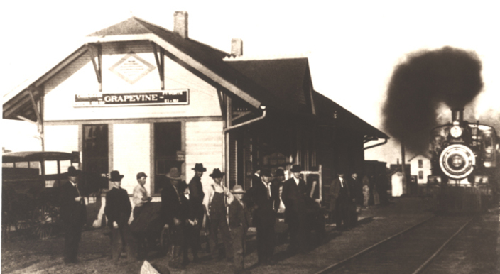](http://www.google.com/url?sa=i&rct=j&q=&esrc=s&source=images&cd=&cad=rja&uact=8&ved=2ahUKEwj80_mxvJvfAhWHq1kKHcAtDRsQjRx6BAgBEAU&url=http://www.ilovegrapevinetexas.com/event/grapevine-easter-train/&psig=AOvVaw1jX9-9LXV21NPuAzZGuoS4&ust=1544744636597667)

**Rail Crew Lunch**

**Cotton Belt Historic Railroad District**

**Saturday Noon – 1:45 p.m.**

Skills & Trades Address – Cody Jolliff, Nash Farm Manager

ALHFAM Mountain Plains Regional Meeting

TLHA Business Meeting & Elections

**Biscuits Saturday 2:00 p.m.**

**Instructor: Kim Pete, Nash Farmhand, Nash Farm, Grapevine, Texas**

**Location: Nash Farmhouse Kitchen**

Everyone loves a good biscuit! Baking powder revolutionized baking in the mid-19th Century. Learn how cooks made their own baking powder and then see how well it works to make a batch of biscuits in the 1892 wood stove.

**Printing Press Operation Saturday 2:00 p.m.**

**Instructor: Brad Dougher, Grapevine Museums, Grapevine Convention & Visitors Bureau, Grapevine, Texas**

**Location: Keeling House, Settlement to City Museums**

Participants will try their hand at printing a Skills & Trades Exposition postcard on the historic Chandler & Price printing press.

**Building and Operating a Spring-Pole Lathe Saturday 2:00 p.m.**

**Instructor: Preston Ware, Graphic Designer & Living Historian,**

**Oklahoma Historical Society, Oklahoma City, Oklahoma**

**Location: Millican’s Blacksmith Shop, Cotton Belt Historic Railroad District**

The spring-pole wood Lathe has been in use for centuries. Archeological findings indicate that the lathe was in use as far back as the Vikings. The lathe uses a spring pole as a return spring for a treadle. Pressing down on the treadle pulls a cord wound around the piece of wood causing it to spin. This session will discuss the construction of a “portable” wood lathe, demonstration of its use, chisels, wood and historical projects that can be turned. If time allows, participants can take a turn using the lathe.

**Learn to Lucet Saturday 2:00 p.m.**

**Instructor: Jodi Larson, Museum Services Coordinator, Lake Jackson Historical Association, Lake Jackson, Texas**

**Participants: 20 max**

**Location: Cotton Gin Museum, Settlement to City**

Learn to use a two pronged knitting fork- called a lucet- in this session. The lucet dates back to the Vikings and has been used ever since (although it is getting rarer!). Using a single strand of string or yarn, the lucet produces a neat, square braid that can be used in many ways. The cordage has a slight stretch that is excellent for drawstrings and lacings! It can also be made into decorative elements. This quick and easy session will show you how to start and end your cord and everything in between. We’ll even have time to add a decorative gimp cord or experiment with ribbon!

**Chicken Care Basics Saturday 2:00 p.m.**

**Instructor: Molly Kemp, Grapevine Apprentice League & Nash Farmhand, Grapevine, Texas**

**Location: Hen House, Nash Farm**

Thinking about raising chickens at home or at your historic site? Molly can tell you all the basics of raising chickens, from breed selection, coop cleaning, feeding, egg production and more.

**Switchel All Around Saturday 3:00 p.m.**

**Instructor: Shawnra Greene, Independent Researcher, Arkansas Living History Association, Mulberry, Arkansas**

**Location: Nash Farmhouse Kitchen**

Switchel was the thirst quencher of the 19th century worker. A compound of a sweetener, ginger, vinegar and water, consult your taste and makeup your own switchel jug!

**Dance instruction Saturday 3:00 p.m.**

**Instructor: Josh Williams, President, Arkansas Living History Association, Washington, Arkansas**

**Location: Nash Pole Barn**

Refresh your dancing knowledge. A quick overview and run through of the dances which are on the dance card for the evening. Don’t be a wall flower because you don’t know the dances!

**“Translating” Historical Knitting Patterns** **Saturday 3:00 p.m**.

**Instructor: Kelsey Patton, Owner- Spindle, Shuttle, and Needle, Stromsburg, Nebraska**

**Volunteer Interpreter, Sturh Museum of the Prairie, Grand Island, Nebraska**

**Location: Cotton Gin Museum**

Historical knitting patterns often use terms that are confusing to our modern knitting minds. What does 4 strand fleecy mean? What do these weird needles sizes mean now? How do I make sense of this strangely written pattern? We will go over common yarns, knitting terms and needles sizes from the past compared to today and “translate” several historical patterns, chosen from period knitting books by the participants.

**Shoe and Leather Care Saturday 3:00 p.m.**

**Instructor: Doug Davis, Owner, Shooting Star Saddlery, Hitchcock, Oklahoma**

**Participants: 15 max**

**Location: Cotton Belt Depot, Cotton Belt Historic Railroad Dist.**

Learn to properly clean and care for your shoes and leather gear so that it will last longer! Small repairs such as the use of pegging awls/ pegs and hand stitching leather will be shown and discussed. Bring a small item such as a pair of shoes, belt or holster to work on.

**Sign Painting Saturday 3:00 p.m.**

**Instructor: Diamond Jim McGinnis, Historic Sign Painter, Grapevine, Texas**

**Location: Founders Building, Cotton Belt Historic Railroad District**

**Participants: 15 max**

Learn the basics of historical sign painting. Diamond Jim has painting many hand-lettered signs in downtown Grapevine and all signs at Nash Farm.

**Volunteers Speak- Roundtable Discussion Saturday 4:00 p.m.**

**Facilitator:** **Amanda Maloney, Vice President, Texas Living History Association**

**Educator, Landmark Inn State Historic Site, Texas Historical Commission**

**Location: Cotton Belt Depot, Cotton Belt Historic Railroad District**

Are you an event coordinator? Hear from the volunteers themselves about what draws them to your sites and events.

Grand Calico Ball

[](http://www.google.com/url?sa=i&rct=j&q=&esrc=s&source=images&cd=&cad=rja&uact=8&ved=2ahUKEwjZ2I6_nITfAhVns1kKHQtpDPUQjRx6BAgBEAU&url=http://www.grapevinetxonline.com/city-links/&psig=AOvVaw3OY6WLUo10IcOsMOJJ0H1_&ust=1543945794652621)Join us for a historic entertaining social evening at the Grand Ball. Calico Balls historically were a fundraiser for the poor. Ladies would wear a calico dress over their ball gown. The calico dresses would be removed to reveal their ball gowns underneath. The calico dresses would then be collected and given to poor of society. There were also other traditions where you would match up calico prints to find your partner for a particular dance at the ball. We have some activities planned including a fun historic fundraiser in keeping with the historic theme. Don’t worry we are not asking you to donate your clothing.

The Grand Calico Ball will feature the Frontier Brigade Band, an American Civil War era brass band. This is a true treat for all attending. Grapevine had a brass town band in the late 19th century and this will be the first time such an affair has been hosted in many years. The evening will take place at the Grapevine Convention & Visitors Bureau at 636 S. Main St. A silent auction will be located on the second floor rotunda and the ball will be held in the Grand Hall.

**The reception and silent auction will begin at 6 p.m. with the Grand Calico Ball at 7 p.m. The evening will also include a short live auction and awards presentations during dancing breaks. The Ball will also include a delectable evening menu of 19th century hearty hors d’oeuvres, punch and of course Grapevine wine.**

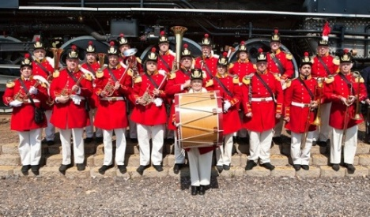**Frontier Brigade Band**

Like the bands of the 19th Century, The Frontier Brigade Band performs at historical events, concerts, period dances, parades, and local civic events. The music library includes quicksteps, waltzes, polkas, gallops, schottisches and ballads from the bandbooks of American Civil War Regimental and Brigade Bands. The band performs on historic style horns including OTS or over-the-shoulder rear facing Saxhorns. Contact the band to inquire about performing at your historic site or museum. [www.FrontierBrigadeBand.com](http://www.FrontierBrigadeBand.com).

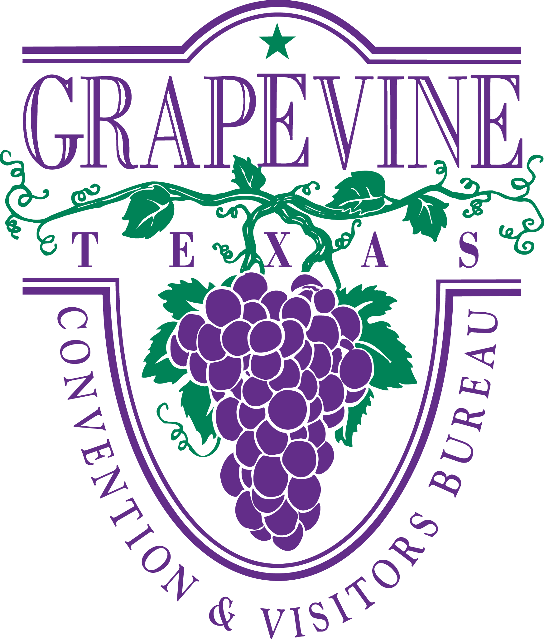***Thanks to the Grapevine Convention & Visitors Bureau & the Grapevine Wine Pouring Society for their sponsorship and support.***

**Sunday, January 27**

8:00 a.m. – 9:00 a.m. Coffee Break at Millican’s Blacksmith Shop

9:00 a.m. – Noon 45min Sessions

Noon Conference Concludes ***Lunch on your own in Historic Downtown Grapevine!***

**Open Anvil Sunday 8-10:00 a.m.**

**Instructor: Millican’s Blacksmith Shop Staff**

**Location: Millican’s Blacksmith Shop**

Interested in Blacksmithing, but not able to take the workshops? Take advantage of an opportunity to try your hand at this come and go session. The forge will be up and running and staff will be on hand to help you see what blacksmithing is all about.

**Moravian Star Ornaments Sunday 9:00 a.m.**

**Instructor: Lisa Rutherford, National Treasure, Cherokee Nation, Tahlequah, Oklahoma**

**Historical Interpreter, Hunters Home, Park Hill, Cherokee Nation, Oklahoma**

**Participants: 10 max**

**Location: Cotton Belt Depot, Cotton Belt Historic Railroad Dist.**

Learn to make a folded paper Moravian Star ornament.

**Carpenter Pencils 101 Sunday 9:00 a.m.**

**Instructor: David Fowler, Regional Historic Sites Director, Oklahoma Historical Society**

**Location: Red Barn Alley, Nash Farm**

Learn the basics of 19th century carpenter’s pencils, history, how to sharpen, how to make marks for cuts and more.

**Distilling for Scents Sunday 9:00 a.m.**

**Instructor: Hannah Kellogg, Site Manager, Sauer-Beckman Living History Farm, LBJ State Park**

**Communications Director, TLHA, Johnson City, Texas**

**Location: Nash Farmhouse Kitchen, Nash Farm**

Ever wanted to teach distilling? Had Trouble figuring out the regulations around making alcohol? Here you can learn the process of distilling while making hydrosols instead of alcohol. Hydrosols- or flower water- were popular for centuries. They were used as perfumes, toners, and medicines. Having a vial of flower water could be useful for a historic impression or for connecting with the museum goer who is excited about essential oils and herbs. At this session you will learn how you can make flower water at home with simple kitchen tools- this way you can create the product you need without major investment. So come learn how to smell the roses from a jar!

**Flossing Corsets Sunday 10:00 a.m.**

**Instructor:** **Kelsey Patton, Owner- Spindle, Shuttle, and Needle, Stromsburg, Nebraska**

**Volunteer Interpreter, Sturh Museum of the Prairie, Grand Island, Nebraska**

**Participants: 10 max**

**Location: Parlor, Nash Farmhouse**

Flossing adds durability, strength, and beauty to your corsets! Learn two different methods of flossing corset boning and take home your own mini sampler.

**Holiday Artistry Sunday10:00 a.m.**

**Instructor: Kay Cynova, Director of Interpretive Resources, Sturh Museum of the Prairie, Grand Island, Nebraska**

**Location: Cotton Belt Depot, Cotton Belt Historic Railroad Dist**.

Examples of Holiday crafts for 9th Century Christmas and Valentines will be explored with the opportunity to try your hand at making these treasures. A materials source list will be at hand.

**Raising Sheep Sunday 10:00 a.m.**

**Instructor: Cody Jolliff, Nash Farm Manager, Grapevine, Texas**

**Location: Red Barn, Nash Farm**

Couldn’t attend the Famers’ Institute but interested in the basics of raising sheep? Participants will help with winter hoof cleaning and trimming.

**Labneh, a Yogurt Cheese Sunday 10:00 a.m.**

**Instructor: Susan Famigletti, Nash Farmhand, Nash Farm, Grapevine, Texas**

**Location: Nash Farmhouse Kitchen**

Learn to make Labneh, a simple middle eastern yogurt cheese. Other types of fresh cheese will also be discussed and taste tested!

**Knife and Tool Sharpening Sunday 11:00 a.m.**

**Instructor: Doug Davis, Owner, Shooting Star Saddlery, Hitchcock, Oklahoma.**

**Participants: 15 max**

Location: Alley of Red Barn, Nash Farm

Tired of trying to saw through things with your pocketknife? Does your hoe bounce off the soil? Do you get more bend than cut with your scythe? Learn to sharpen knives and tools correctly using stones, files, strops and other period sharpeners. Bring a knife or tool to sharpen! The farm has plenty if you don’t have your own.

**Let Them Eat Cake: How Margaret Houston, Imperial Sugar, and Family Lore Collide Sunday 11:00 a.m.**

**Instructor: Taylon Black**

**Location: Nash Farmhouse Kitchen**

A historic bake-off. Using Margaret Houston’s famous white cake recipe as the starting point, participants will test a variety of recipes made using various historic cookbooks.

**Simple Scherenschnitte Sunday 11:00 a.m.**

**Instructor: Jodi Larson, Museum Services Coordinator, Lake Jackson Historical Association, Lake Jackson, Texas**

**Location: Cotton Belt Depot, Cotton Belt Historic Railroad Dist**.

Take ordinary paper and snip, snip, snip your way to a rural art from. This session will introduce beginners to using scissors (both 19th century and modern) as well as shears- yes like sheep shears- to create traditional craft from plain paper. This session will cover simple designs like accordion dolls and a few ethnic traditions from northern Europe, perhaps Scandinavian Kurbits or the Polish “Tree of Life”. Even if you’ve done papercutting before, this useful session will prepare you for “doodling with scissors” in a period appropriate way.

**All About Eggs Sunday 11:00 a.m.**

**Instructor: Enoch Doubledee, Nash Farmhand, Nash Farm, Grapevine, Texas**

**Location: Hen House & Nash Farmhouse Kitchen**

Learn how to Judge and Grade Eggs. Using the tools of the trade, participants will get the chance to try their hand at grading, candleing and judging eggs.

**Lunch on your own in Historic Downtown Grapevine!**

***Thanks for visiting Grapevine, Texas! Safe Travels!***

***Conference Registration online at www.*TexasLivingHistoryAssociation.org**

|  |  |  |  |  |
| --- | --- | --- | --- | --- |
| **Item** |  | **Price** | **#** | **Total** |
| **Full Conference Registration** | **TLHA & ALHFAM** | **$75.00** |  |  |
| *Full Conference Registration (Non- Member)* | *(Non-Member)* | *$90.00* |  |  |
| **T-Shirt Size** |  | ***FREE*** |  | **Size:** |
| ***Extra Ticket to Grand Calico Ball*** | ***Saturday Night*** | ***$25.00*** |  |  |
| **Farmers Institute** | **Thursday & Friday** | **$50.00** |  |  |
| **Two Day Wrapper Dress Workshop** | **Thursday & Friday** | **$90.00** |  |  |
| **Rail Crew Academy** | **Thursday** | **$50.00** |  |  |
| **Make a Steel Striker** | **Thursday 9am - Noon** | **$30.00** |  |  |
| **Forge Welding Primer** | **Thursday 1pm-4pm** | **$30.00** |  |  |
| **Wine & Viticulture Class, Tour & Tasting** | **Thursday 3:30pm – 5:30pm** | **$30.00** |  |  |
| **Historic Downtown Grapevine Walking Tour** | **Thursday 9am-11am** | **FREE** |  |  |
| **Historic Building Architectural Tour** | **Thursday 1pm-3pm** | **FREE** |  |  |
| **The Sheep are Sheared, Now What?** | **Friday 9am-4pm** | **$30.00** |  |  |
| **Historic Land Surveying** | **Friday 9am-4pm** | **$30.00** |  |  |
| **Basic Blacksmithing** | **Friday 9am-4pm** | **$30.00** |  |  |
| **Historic Broom Making** | **Friday 9am-4pm** | **$45.00** |  |  |
| **Cooking for a Social Event** | **Friday 9am-4pm** | **$30.00** |  |  |
| **Constructing Canvas: Tent Setup** | **Friday 9am-Noon** | **$10.00** |  |  |
| **Spark & Flame: Historic Fire Making** | **Friday 9am- Noon** | **$30.00** |  |  |
| **Rags to Rugs** | **Friday 1pm-3pm** | **$25.00** |  |  |
| **Flints, Caps, Cartridges: Firearms of the Past** | **Friday 1pm-4pm** | **$30.00** |  |  |
| **Total Amount Due:** | **\*\*\*\*\*\*\*\*\*\*\*\*\*\*\*\*\*\*\*\*\*\*\*** | **\*\*\*\*\*\*** |  | **$** |

**Questions? Call Cody or Kimberly at Nash Farm 817-410-3558 or email** [**CJolliff@GrapevineTexasUSA.com**](mailto:CJolliff@GrapevineTexasUSA.com)

**Name: ____________________________________________**

**Address: ____________________________________________**

**____________________________________________**

**Email: ____________________________________________**

**Phone: ____________________________________________**

**Historic Site: ____________________________________________**

**Title: ____________________________________________**

***To Register by mail, send to:*  Nash Farm 636 S. Main St. Grapevine, Texas 76051**